 | PORTISHEAD TOWN  WALKING FOOTBALL GROUP  Medical Emergency Action Plan (MEAP)

IMPORTANT | For each & every session ensure at least two people have mobile phones with a good signal & charged battery easily located if a medical emergency situation arises.
[1] | ESSENTIAL INFORMATION:
Location | PTFC Bristol Road, Portishead, BS20 6QG
Telephone | 01275 817600
What 3 Words | Outbound – Alarmed – Rushed
Player Details  Medical & NoK | Permanently in session kit bag (document includes player medical notes)
First Aiders | Paul Tucker, Rod Sowden, Mat Gillet, Neal Smith, Colin Barnes,
Stretcher | Hospitality room pitch side
First Aid Kit | In session kit bag and one in each pitch side changing room
Ice Packs | In every session kit bag
Defibrillators | - Attached to 3G Perimeter fencing - see photograph below.  The access code is provided by Emergency services when you call 112 or 999 and advise your location.  - Exterior wall of PTFC Clubhouse – see photograph below  To the left of the lefthand set of doors to Clubhouse.
Location (1) | 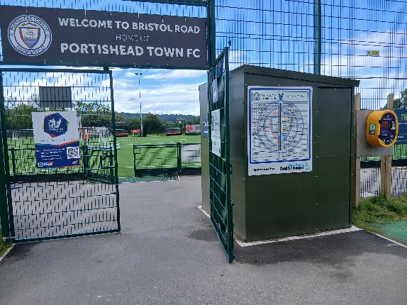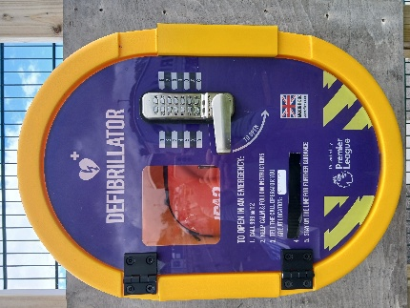
Location (2) | 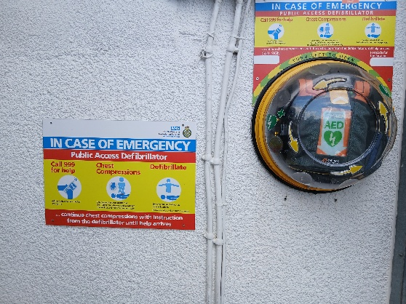
PORTISHEAD TOWN
WALKING FOOTBALL GROUP
Medical Emergency Action Plan (MEAP)

IMPORTANT | For each & every session ensure at least two people have mobile phones with a good signal & charged battery easily located if an emergency situation arises.
[1] | ESSENTIAL INFORMATION:
Location | Go Shine Sports Centre (Gordano), St Mary’s Road, Portishead, BS20 7QR.  NOTE: staff have no knowledge of a MEAP for Go Shine centre.
Telephone | 01275 404844 or 07353 100708 (staff on site contact number).  Always advise Go Shine reception if a medical emergency situation arises
What 3 Words | Not known
Player Details  Medical & NoK | Permanently in session kit bag (document includes medical notes)
First Aiders | Paul Tucker, Rod Sowden, Mat Gillet, Neal Smith, Colin Barnes,
First Aid Kit | In session kit bag
Ice Packs | In every session kit bag
Defibrillator | In main reception on wall behind desk  See photographs below –
Location | 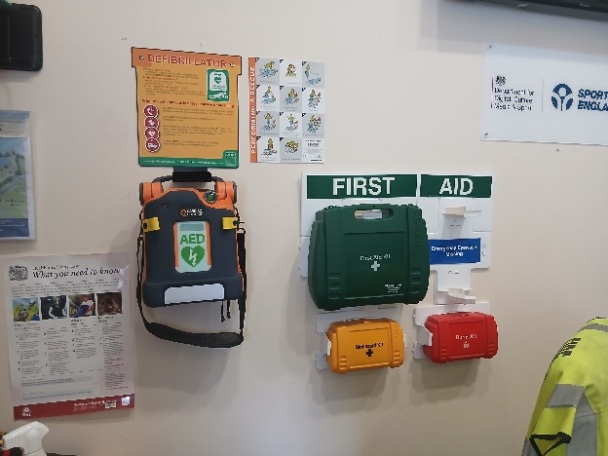
Bleed Kit | On exterior wall to left of main entrance to Sports Centre, see photo below –  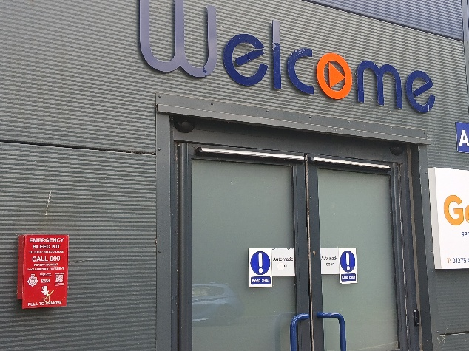

[2] KEY ACTIONS: DR A-E procedure
D = DANGER.
- Check it is safe to approach the player, has play been stopped, remove any obstacles.
- Did you witness the mechanism of injury?
- Are you concerned about a neck or spine injury?
- Is the player conscious?

R = RESPONSIVENESS
- Alert – is the player speaking and attentive?
- Confusion – is the player awake/conscious but seemingly disorientated?
- Verbal – does the player respond when you speak to them?
- Pain – does the player respond to stimulus, a stroke of the face, a tweak of the ear lobe?
- Unresponsive – if the player does not react to any of the above –
(a) call 112/999 immediately
(b) start CPR immediately
(c) fetch a defibrillator immediately.
A = AIRWAY
- Check nothing solid is blocking the airway, e.g. rubber crumb, chewing gum. Try to remove without placing your fingers in the mouth
- To open airway tilt head/chin
B = BREATHING
- look for rise/fall of chest and use back of hand near mouth to check for breath.
- Normal breathing is 10 breaths per minute and both sides of the chest moving equally
- IF NOT BREATHING START CPR IMMEDIATELY AND FETCH DEFIBRILLATOR
C = CIRCULATION
- Is the player obviously bleeding, staunch cut if severe with risk of bleeding out.
- Is the player’s face pale or mottled in colour?
- Is player hot or cold to touch?
D = DYSFUNCTION
  - Repeat AcVPU checks every couple of minutes for any variation.
E = ESSENTIAL ACTIONS
  - Start CPR and fetch defibrillator and call 112 or 999.
  - Someone must manage the scene & direct persons (see below).
  - Maintain CPR (have persons ready to take their turn) until defibrillator arrives
  - Person making the 112/999 call and having the defibrillator must always remain in direct contact with emergency call handler who will provide running commentary support.
  - Obtain Player Registrations document from kit bag and check whether the casualty has any medical conditions and/or medication and/or allergies.
  - Follow the guidance of the emergency call handler and inform first responders of any relevant information e.g. estimated time of arrival of the ambulance.
  - If relevant, refer to documents covering –
Resuscitation, Concussion, Asthma and Anaphlaxsia – all in kit bag folder

- MANAGING THE SCENE & SUPPORT ACTIONS

- One person must assume overall control of the scene & direct other persons

- Make space for CPR and defibrillator operators – they need back-up, it is exhausting
- Is the casualty cold/wet/hot – action accordingly.
- Deploy a person(s) to Main Road and any turnings to direct ambulance.
- Ensure ambulance can park as close as possible – ask car owners to move vehicles.
- Ensure exit route for ambulance remains clear.
- If air ambulance is called -
- at PTFC it will land on adjacent grass football pitches
- at Go Shine (Gordano) it will land on “Top Field” adjacent to blue astro pitch.
Deploy persons to direct the crew whilst maintaining a safe distance from landing area.

- Ideally, record actions/times to pass on to emergency personnel when they arrive.

[3] MEDICAL SERVICES:
HOSPITALS
SOUTHMEAD, Southmead Road, Westbury-on-Trym, Bristol,BS10 5NB
Tel: 0117 342 1000 (Emergency Dept) 0117 923 0000 (Switchboard)
By road 12 miles, journey time minimum 25 minutes
BRISTOL ROYAL INFIRMARY, Upper Maudlin Street, Bristol BR2 8HW
Tel: 0117 950 5050 (Switchboard)
By road 9 miles, journey time minimum 35 minutes
WESTERN GENERAL, Grange Road, Uphill, Weston-Super-Mare, Avon, BS23 4TQ
Tel: 01934 636363 (Switchboard)
By road 20 miles, journey time minimum 40 minutes
CLEVEDON (MINOR INJURIES UNIT), Old Street, Clevedon, BS21 6BS
Tel: 01275 546852 (Switchboard)
By road 5 miles, journey time 12 minutes
NOTE: all journey times are likely to be subject to delays due to traffic conditions particulary at peak period of the day.

